Appendix B

Preliminary Design for Satellite Tracking Upgrades
for Site 515 Antennas

Overview of Existing Antenna Drive System

The existing antenna drive system was designed for tracking of celestial objects, and is also capable of slewing at higher speeds for setting up observations, as well as moving the dish to its stow position during high wind conditions. The declination (DEC) drive can move the antenna in a continuous north-south arc, from its stow position pointing to the North Star (Polaris, at +90 deg DEC) to the southern horizon. The hour angle (HA) drive can move the antenna in a continuous east-west arc horizon-to-horizon. The location of these drives and their effect on dish movement are shown in the diagram below:

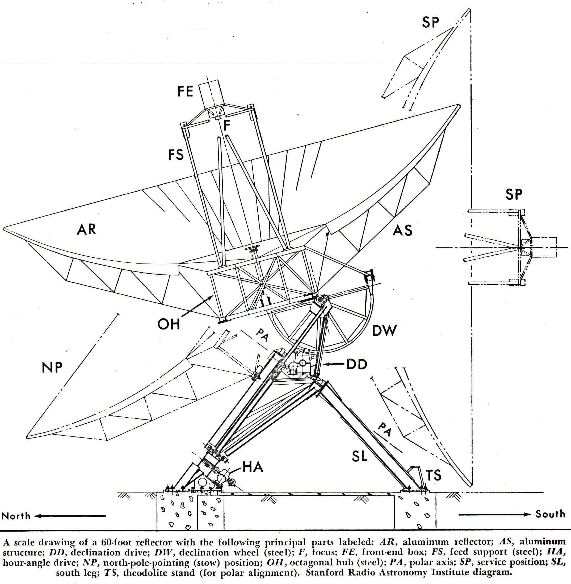
DEC Drive (DD)
North-South
Movement
HA Drive
(HA)
East-West Movement

Existing Declination (DEC) and Hour Angle (HA) Drives
Based on the schematic below for the existing drives, we can see that the fastest speeds currently produced when slewing are:

DEC drive current max speed (“1X”) = .046 RPM ( = 16.5 degrees per minute in north-south movement)

HA dive current max speed (“1X”) = .0206 RPM (=7.5 degrees per minute in east-west movement)

For simplicity, we will refer these speeds as the “1X” speeds for DEC and HA respectively.

DEC Drive
HA Drive
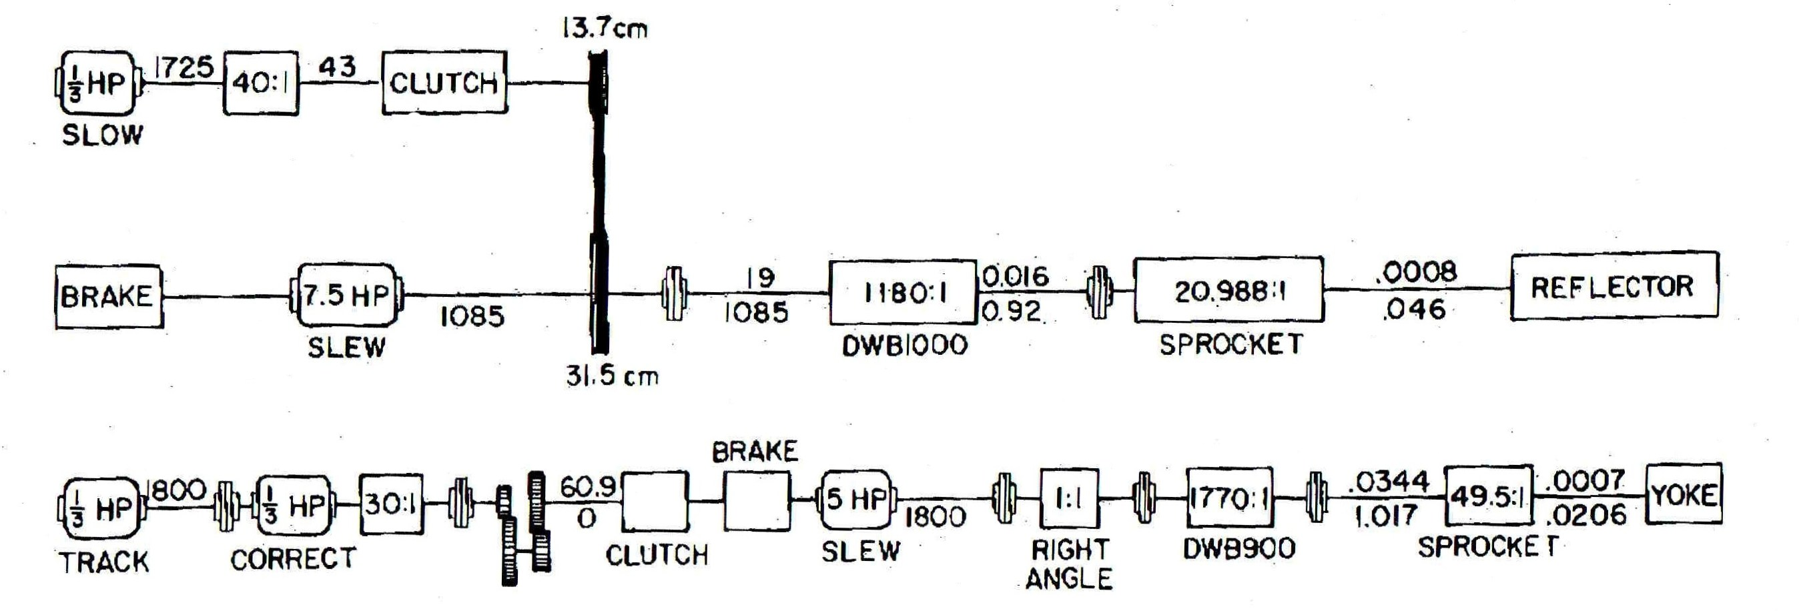

Schematic for Existing Declination (DEC) and Hour Angle (HA) Drive Trains

(Note: The numbers shown above are in RPM units. The RPM values shown above the shaft lines are for the DEC slow and HA track/correct modes, and the RPM values below the shaft line are for high speed slew mode).

Tracking Speed Increase Requirements for Low Earth Orbit (LEO) Satellites

To determine the tracking speed increases needed for Stanford CubeSats in low earth orbit (LEO), we ran simulations for 1000 visible passes over Stanford corresponding to a 6 month tracking period. The percent acquirable time as a function of tracking speed was then plotted for each drive:
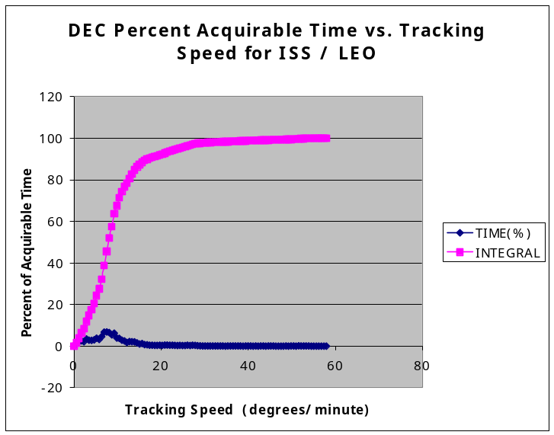
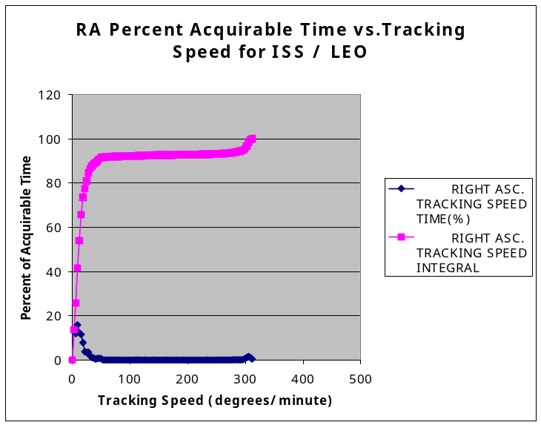

Percent acquirable time as a function of tracking speed for the DEC and RA drives
for Stanford CubeSats in Low Earth Orbit

Based on the above curves, we can summarize the effect of a range of possible speed increases (1X through 10X) on percent acquirable time as follows:

 | 1X | 2X | 3X | 4X | 5X | 10X
DEC Drive | 89% | [98%] | 99% | 100% | 100% | 100%
HA Drive | 30% | 65% | 77% | [85%] | 88% | 92%

Now, if we apply the criteria that we would like to be able to view the satellite about 85% of the time on average for all visible passes, we therefore need to increase the speed of the HA drive by 4X, and increase the speed of the DEC drive by 2X.

This gives us:
HA (at 4X) = 30 degrees per minute

DEC (at 2X) = 33 degrees per minute

Note that the 85% figure is best case, as any obstructions near the horizon may limit the actual viewable arc.
Tracking Speed Increase Requirements for Geosynchronous Transfer Orbit (GTO), Geosynchronous Orbit (GEO), Lunar Flyby, and Deep Space Mission Satellites

The tracking speed requirements for these orbits and trajectories are less than for Low Earth Orbit (LEO) satellites, and therefore will be satisfied with the proposed speed increase for LEO.

In the case of GTO orbits, even though the dish will need to reverse its movement to follow a retrograde loop at apogee, the actual speed needed at that time will be quite low.

Tracking Speed Upgrade Modifications

To achieve a 2X speed increase in DEC, and a 4X speed increase in HA, the following upgrades are proposed:

Upgrade existing 7.5 HP 1085 RPM motor with a 15 HP 3600 RPM motor (variable speed inverter duty type, 208V, 3 Phase) for 2X HP and 2X RPM (electronically speed controlled to 2170 RPM and under).

2X
DEC Drive

4X
HA Drive

Upgrade existing 5HP 1800 RPM motor with a 20 HP 3600 RPM motor (variable speed inverter duty type, 208V, 3 Phase) for 4X HP and 2X RPM.
Change gearing in DBW900 reducer from 1770:1 to 885:1 for additional 2X RPM

Preliminary Design for Satellite Tracking Control System

An overall block diagram for the satellite tracking control system design is shown below:
Stanford Space Systems
Development Laboratory (SSDL)
Remote PC

Real-time Antenna Tracking Control System
Server
In Site 515 Control Room

- Satellite tracking motion control program

- Real-time satellite coordinates generated by PREDICT 2.2.1d using updated NORAD TLE’s

- OS: Linux / Real-time System

Antennas
NORAD TLE
File Update Site

(Downloadable Two Line Element files with updated satellite orbit measurements based on NORAD tracking)

Internet

Analog & Digital Data Acquisition PCI Card
Boundary Switches
Limit switches
Received Signal Strength

RS485 PCI Interface Card (2 Port)

Hitachi 20 HP Motor Variable Speed Control
HA 4X Drive
(Variable Frequency Inverter)
L300P-150LFU2 or similar

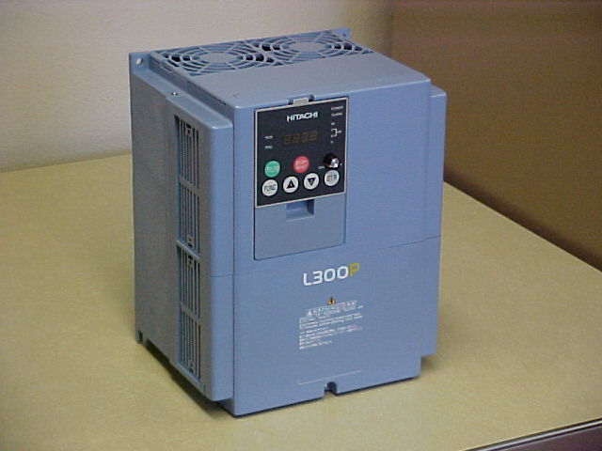
Hitachi 15 HP Motor Variable Speed Control
DEC 2X Drive
(Variable Frequency Inverter)
L300P-110LFU2 or similar

Incremental Encoder
PCI Interface Card

HA 4X Drive Motor
20 HP, 3600 RPM
(WEG 02036EP3E256T or similar)
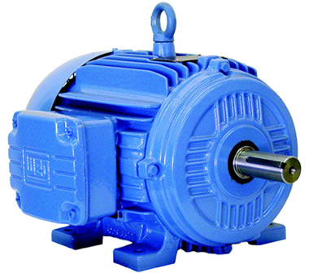
DEC 2X Drive Motor
15 HP, 3600 RPM
(WEG 01536EP3E254T or similar)

HA Encoder
(Incremental type, pinion for existing HA rack)
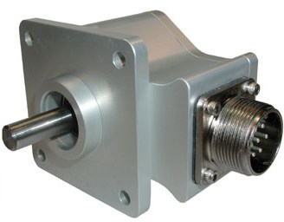

DEC Encoder
(Incremental type, pinion for existing DEC rack)
As illustrated above, the satellite tracking and antenna motion control functions are handled by a real-time antenna tracking control server in the existing Site 515 Control Room. To achieve robust performance at low cost, the Satellite Tracking and Motion Control Program will be running on an Intel-based PC running a real-time variant of the Linux operating system.

The Motion Control program will obtain real-time satellite coordinates by calling PREDICT 2.2.1d, a widely used open-source satellite tracking program that generates real-time ALT-AZ coordinates for driving telescope motion control systems. PREDICT 2.2.1d generates its coordinates using updated NORAD Two Line Element (TLE) orbital description files. A UNIX CRON job running on the server will automatically download the most recently updated TLE files at regular intervals from a NORAD Internet mirror.

Based on the actual antenna position measured by incremental encoders, and the desired antenna position derived from the real-time satellite coordinates, the Motion Control program will servo the HA and DEC drive motors to minimize the positional difference, using standard closed-loop control methods. Motor acceleration/deceleration rates will be controlled to maintain impulse forces within original design (1X) limits.

As an added enhancement, once the antenna is tracking, the Motion Control system will measure the satellite’s received signal strength, and “wobble” the beam in small (1/4 beamwidth) offsets to fine-tune the positioning for maximum signal strength.

To accurately determine the current HA and DEC position, modern incremental encoders (such as the US Digital HD-25 Industrial Rugged Sealed Optical Encoder, 2 channels in quadrature, 400 pulses per revolution) will be installed adjacent to the existing SLO-SYN synchro motor encoders, for improved reliability, PC compatibility, and tracking performance. The new encoders will be pinion-coupled and driven by the HA and DEC racks in the same manner as the original encoders. The encoders interface to the PC by means of an incremental encoder PCI card.

The Motion Control server controls the speed of the HA and DEC drives by means of electronic variable speed motor controls (Hitachi L300P Variable Frequency Inverters, or similar) through an RS485 PCI interface card. These speed controllers in turn connect to the 3-phase 208V motors, which are rated for inverter drive duty (WEG Totally Enclosed Fan Cooled [TEFC] Inverter Duty Series or similar).

To provide multiple back-up systems so that the antenna cannot be driven beyond its HA and DEC limits, the existing boundary mercury switches will be sensed as a motion cutoff backup. In addition, the existing mechanical microswitch limit switches will be hardwired to directly interrupt motor power in the event the dish should move to these limits.

The Stanford Space Systems Development Laboratory (SSDL) can control and monitor real-time tracking operations by means of a remote PC using a secure SSH connection to the Satellite Tracking Control Server via the Internet.

Satellite Tracking Upgrade Material Cost Estimate

Quan. | Description | Ea. | Total
1 | Tracking Control Intel PC Server (being donated) | $ 0. | $ 0.
1 | RS-485 Dual Port PCI Card | 99. | 99.
1 | Hitachi 20 HP Variable Frequency Inverter | 1,225. | 1,225.
1 | Hitachi 15 HP Variable Frequency Inverter | 940. | 940.
1 | WEG 15HP 3600 RPM 208V 3-Ph. Inverter Duty Motor | 580. | 580.
1 | WEG 20 HP 3600 RPM 208V 3-Ph. Inverter Duty Motor | 665. | 665.
2 | US Digital HD-25 Industrial Sealed Optical Encoder | 280. | 560.
1 | Incremental Encoder PCI Interface Card, US Dig PCI-4E | 350. | 350.
1 | Analog & Digital Data Acquisition PCI Card | 650. | 650.
 | TOTAL (less tax and shipping): [Note 2] |  | $ 5,069

Note 1: Gearing change cost for DBW900 reducer TBD.

Note 2: An initial $20,000 gift has been made to STAR Lab by supporters of the Friends of the Bracewell Observatory Association which is intended to be applied to the initial restoration of the 1st dish, and its associated satellite tracking upgrades for SSDL missions, building restoration and utilities.

