Your Name

111 Your Street, Your City, Yourstate Yourzip Ph: 111-111-1111

VIA FAX: «Business_Fax»

July 30, 2026

«Title» «First_Name» «Last_Name»
U.S. Senate
Washington, DC 20515

Dear «Title» «Last_Name»,

An ABC News poll revealed that 85% of Americans say that global warming is real. So do the scientists. Considering how grave climate change is, it's shocking that many leaders in government have not taken steps to address what is one of the greatest crises in the history of our planet.

It’s time for action now.

It’s time to pass real solutions, including reducing emissions, investing in clean and renewable energy, and placing a cap on global warming pollution. We do have the tools and technology to tackle this enormous problem. Help us take control of our energy future, so that we can reinvigorate our economy and protect our environment.

I urge you to support comprehensive clean energy and climate legislation what will:
- Create millions of new American manufacturing and construction jobs for workers installing wind turbines, retrofitting buildings and building the next generation of fuel efficient cars.
- Reduce our dependence on foreign oil that sends our dollars — nearly $1 billion a day — abroad.
We must cap pollution that causes the climate crisis at a level that matches what science tells us is necessary.

Best wishes,

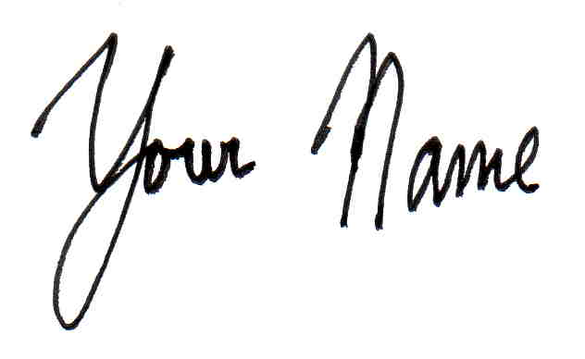

Your Name

